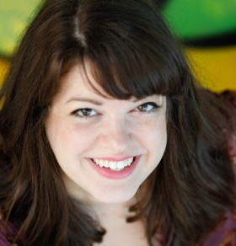
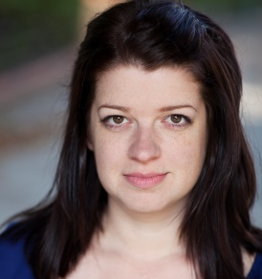
MEREDITH BARTMON
-_AEA – UK EQUITY_
~www.meredithbartmon.com~
Email: Meredith.Bartmon@gmail.com
Phone: 561 350 8012
Voice Type: Mezzo-Soprano

REGIONAL
Equus (Upcoming) Nurse J.Barry Lewis Palm Beach Dramaworks
The Humans* Aimee Blake Joe Adler Gablestage
1984 Syme Skye Whitcomb Outre Theatre Company
Summer Shorts ** Evelyn Shaffer/Etc. Margeret Ledford City Theatre
Hello, Dolly!** Ernestina Money Lee Roy Reams The Wick Theatre
South Pacific Lt. Genevieve Norb Joerder The Wick Theatre
Sister Act/Sound of Music Nunsemble Michael Ursua The Wick Theatre
Lazy Fair by Theo Reyna Sandra Theo Reyna Mad Cat Theatre
Little Women Beth Matt Stabile WLRN Radio Theater
Plan 9 from Outer Space Tanna Matt Stabile WLRN Radio Theater
Midsummer Night’s Dream Titania Trent Stephens Ann Norton Gardens
The Rothschilds Gutele Rothschild Peter J. Loewy Broward Stage Door
Crimes of the Heart Lenny Magrath Michael Leeds Broward Stage Door
Promises, Promises Miss Peggy Olson Michael Leeds Broward Stage Door
Kiss of the Spider Woman Marta Patrick Fitzwater Slow Burn Theatre
Assassins Emma Goldman Patrick Fitzwater Slow Burn Theatre
Fly Over Country Adelaide Carolyn Michel Florida Studio Theatre (Reading)
Silverhill Annie Major William Hayes Florida Stage (Reading)
Rock N’ Roll by Stoppard Magda/Gillian Richard J Simon Mosaic Theatre
*Nominated: Carbonell Award for Best Supporting Actress in a Play (Ceremony Apr 2, 2018)
** Winner: Silver Palm Award for Outstanding New Talent 2016

UK THEATRE
Archipelago (Game Theatre) Mainland Delegate James Harper Hobo Theatre (USA/UK)
The Roundabout Magdalena James Harper Bush Theatre Bazaar
L’Hotel Du Cirque Sadie͑͑ Andrea Brooks The Cockpit Theatre (Devised)
ARK Lilah Oli Forsyth Downpour Theatre (Devised)
You Me Bum Bum Train Radio Caller K. Bond/M. Lloyd Theatre Royal Stratford East

NATIONAL TOUR
King Arthur’s Quest Narrator Missoula Children’s Theatre

TRAINING
East 15 Acting School MA Acting London, UK
New World School of the Arts BFA Music Theatre Miami, FL
SpringboardNYC/American Theatre Wing Music Theatre New York City

SKILLS: Dialects (Highly Skilled at British RP/Irish, London & American Regional), Radio Theatre, Shakespeare (Highly Skilled), Movement, Understudy/Swing Experience – With Perf., Living History/ Long-form Immersive Improvisation, Devising, Stage Combat - BADC UK Foundation Training.

